LAB ACTIVITY 4(ii):

Writing Functions In Python

**Learning Outcomes:**

By the end of this laboratory session, you should be able to:

1. Construct Python function for returning result using return statement
2. Follow rules for local and global scope in function
3. Construct Tuples and use it in simple Python program
4. Construct Dictionary and use it in simple Python program

**Hardware/Software:** Computer, Phyton 3.5 or above.

**Activity 4F**

Activity Outcome**:** Creating and calling a simple function

Procedure:

**Step 1:** Open Code editor and type the code based on the following code :

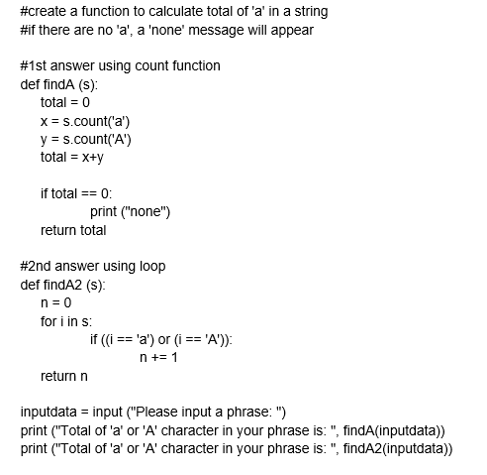

**Step 2:** Save, compile and run the program. Save the program as Act4F.py. Display the output in the area below.

**Output:**



**Activity 4G**

Activity Outcome: Creating and calling a recursive function.

Procedure:

**Step 1:** Open code editor and type the following code:

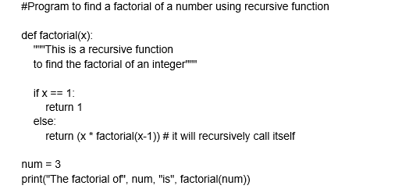

**Step 2:** Save, compile and run the program. Save the program as Act4G.py. Display the output in the area below.

**Output:**



**Activity 4H**

Activity Outcome : Follow rules of local and global scope in function.

Procedures:

**Step 1:** Open code editor and type the following code:

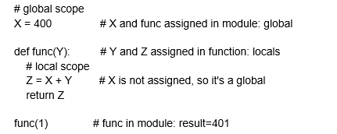

**Step 2:**  Save, compile and run the program. Save the program as Act4H.py. Display the output in the area below.

**Output:**



**Activity 4I**

Activity Outcome : Follow rules of local and global scope in function (using global variable in a function).

Procedures:

**Step 1:** Open code editor and type the following code:

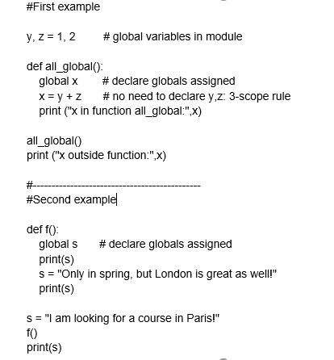

**Step 2:**  Save, compile and run the program. Save the program as Act4I.py. Display the output in the area below.

**Output:**

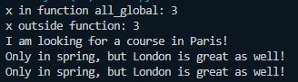

**Activity 4J**

Activity Outcome : Construct Tuples in Python

Procedures:

**Step 1:** Open code editor and type the following code:

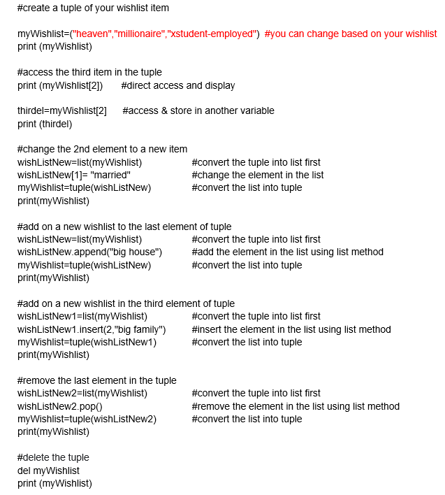

**Step 2:**  Save, compile, and run the program. Save the program as Act4J.py. Display the output in the area below.

**Output:**

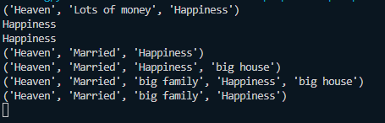

**Activity 4K**

Activity Outcome : Construct Dictionary in Python

Procedures:

**Step 1:** Open code editor and type the following code:

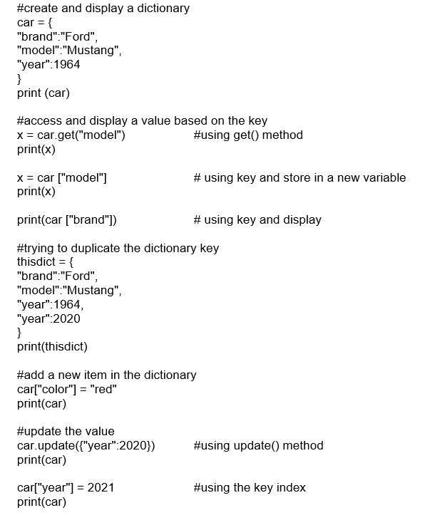

**Step 2:**  Save, compile and run the program. Save the program as Act4K.py. Display the output in the area below.

**Output:**

**Activity 4L**

Activity Outcome : Construct Dictionary in Python

Procedures:

**Step 1:** Open code editor and type the following code:

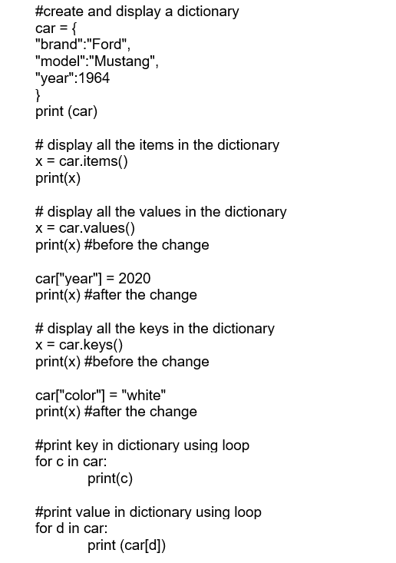

**Step 2:**  Save, compile and run the program. Save the program as Act4L.py. Display the output in the area below.

**Output:**

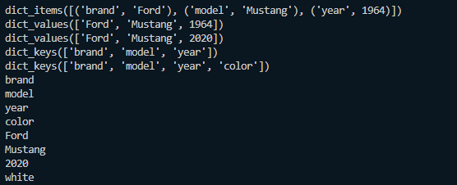

**Activity 4M**

Activity Outcome : Construct Dictionary in Python

Procedures:

**Step 1:** Open code editor and type the following code:

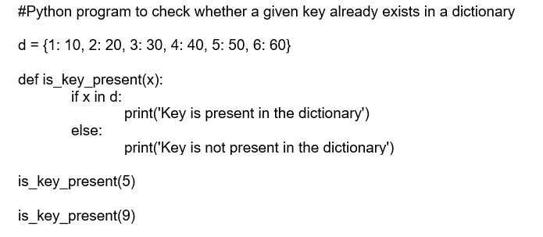

**Step 2:**  Save, compile and run the program. Save the program as Act4M.py. Display the output in the area below.

**Output:**

